Creating a macro in MS Word.

Prepared by: Michael Fiore, BSE, MBA ©2007

Let's get started.
- Open a new Word document
- Type in a few words of text. Anything you like
- Highlight your text, or just a single word of the text
- From the menu bar, click on Tools
- From the drop down menu click on Macro
- A sub menu appears
- Click on Record New Macro
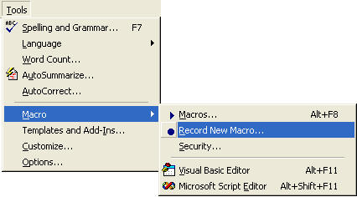
When you click on Record New Macro, you get the Macro dialogue box popping up. It looks like the one below:
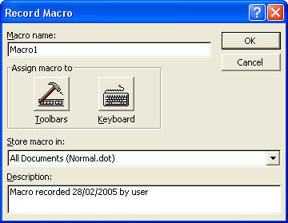
There are four areas to the Record Macro dialogue box: Macro Name, Assign macro to, Store macro in, and Description.
The first thing to do is to give your macro a name. At the moment it is called "Macro1". That's not a very descriptive name for what we want our macro to do. We'll call our macro FontChanger. Notice that we haven't put a space between the two words. This is because macros don't like having spaces between words. You have to put the name of your macro as all one word.
So go ahead and type in FontChanger as the Macro name, instead of Macro1.
The next section is "Assign macro to". You are given the choice of either Toolbars or Keyboard. Ignore this section for now. We'll see later how to assign our macro to a toolbar, and to the keyboard.
The next section is "Store macro in". At the moment it reads All Documents (Normal.dot). Remember what Normal.dot is? That's the basic template for all Microsoft Word documents. In other words, the macro we create will be available to any new Word document. You can change this so that the macro is created in only the document you're working on. Click the black down arrow to see the title of the document you have open.
The final section is Description. This is just a record of when the macro was created, and who created it. You can change this to anything you like. Malicious folk creating nasty macros will definitely change these details.
Once you have given your macro a name, click the OK button. Your dialogue box will look like this:
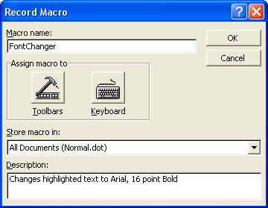
When you click the OK button, you are returned to your Word document. But now you will see a strange toolbar floating over your page. And the mouse pointer will be different. Your page will look like this:
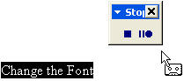
The reason the little floating toolbar says Stop is because your macro is already being recorded. The process has started. You don't have to panic, and hurry it along. Take your time and think about what you're going to do.
The floating toolbar, though, has only two buttons. The square one is the stop button; the two lines and the circle is the pause button. Notice that the mouse pointer has changed, with a little cassette tape on the end of it. This indicates that you are recording a macro.
One thing you can't do with a macro is record mouse movements. If you want to move your cursor somewhere in your text, you'll have to use the arrow keys on your keyboard. But the movement of the cursor then becomes part of your macro.
For our macro, because we highlighted the text before recording, we don't need to move the cursor. Whatever we do from now on will become part of our macro.
- So click on Format from the menu bar
- From the drop down menu, click on Font
- The Font dialogue box appears
- Select Arial as your font
- Select Bold
- Select size 16
- Click the OK button on the Font dialogue box
- You are returned to your page
- Click the Stop button on your floating Macro Recorder
- The macro will stop recording, and the process is finished: You have recorded the macro
If you make a mistake during the recording of your macro, and everything goes horrendously and badly wrong, you can abort the recording and try again. To abort your recording and try again, do the following:
- Click the Stop button on your recorder
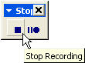
- The recorder disappears
- Click Tools > Macro > Record New Macro
- In the Macro name part of the dialogue box that pops up, type in the name of the macro that went wrong. In our case that would be FontChanger.
- Click OK
- Word displays a message box telling you that a macro with that name already exists. It asks if you want to replace it
- Click Yes
- You are returned to your document, and the recorder is displayed
- You can now try again
- If things go wrong again, repeat these instructions
If nothing went wrong, you will now have a macro. So how do you get at it? To use your new macro, do the following
- Type in some new text and Highlight it
- Click on Tools from the menu bar
- From the drop down menu, click on Macro
- From the sub menu that appears, click on Macros
- The Macros dialogue box appears:
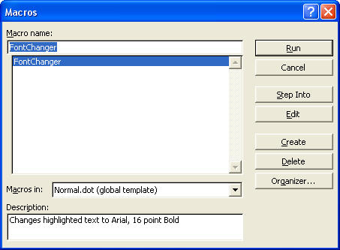
Select the Macro that you want, then click the Run button at the top right of the dialogue box. As you can see, the macro we created is in the list, and already highlighted. When the Run button is clicked, the dialogue box will disappear, and the highlighted text will change to Arial, Bold 16 points.
You might argue that by clicking on Tools > Macro > Macros, and then fiddling about with the dialogue box is not exactly a shortcut. Surely it's just as easy to click on Format > Font, and make your changes from there?
The makers of Microsoft Word fully agree with that argument. That is why they give you the option to access your shortcut from the toolbar or the keyboard. We'll see how to do that now.
OK, we'll create another new macro. This macro will add a background shade to a line of text. Like this one below:
Except our macro won't add the text - it will just add the shade to any line we choose. And we're going to create this macro in the toolbar. We'll see how to add a button in any toolbar. When we want to shade a line of text, all we need to do is click the button. We don't have to open the Borders and Shading dialogue box.
So let's make a start.
- Click Tools > Macro > Record New Macro
- The Macro dialogue box appears
- Type in a new name for your macro. Call it ShadeLine
- Click the Toolbar icon
- Another dialogue box appears:
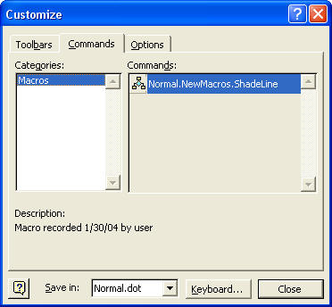
This is where the fun starts! The idea now is drag your macro to a toolbar and drop it. Your macro is the one under "Commands". Ours says Normal.NewMacros.ShadeLine, and there's a little icon to the left if it. To drag it to a toolbar, do the following.
- Click on your macro Normal.NewMacros.ShadeLine with your left mouse button
- Keep your left mouse button held down
- Drag your mouse upwards
Keep your eyes on the mouse pointer. As soon as you start dragging it will look like the one below:
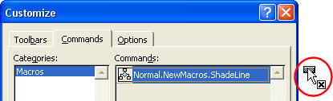
Notice the mouse pointer, circled in red above. This is what it looks like when you hold down your left mouse button and start dragging. Pay particular attention to the black X just below the white arrow. The black X means that you can't drop your macro in that position.
In the next picture, the mouse button is held down and the macro is being dragged to the toolbar area:
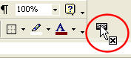
The macro is now on a grey area of the toolbar. Notice that the black X is still there. So we can't drop our macro here, either. The left mouse button is still being held down, by the way.
In this next picture the macro is now being dragged onto a toolbar itself:
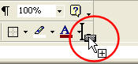
The thing to notice now is the black X below the white mouse pointer is no longer there. We now have a plus + sign. There is also a black I bar. What all this means is that you can now let go of the left mouse button. You have found a place where it is possible to drag your macro - on a toolbar.
When you let go of your mouse, your toolbar will look like this:
That's your macro right there! Or rather, it is the button for your macro. When this button is clicked, it will run your macro. (We haven't created the macro itself yet. We're just setting up the toolbar button for it.)
The button looks a bit big and messy. We can format it.
- Click on your new button with your Right mouse button
- A menu appears
- Move your mouse down to Change Button Image
- A sub menu appears with lots of little pictures on it. Like the one below:
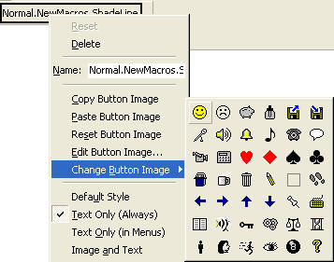
· Click on any of the pictures with you left mouse button
· The menu closes and the picture appears on your button
· Your toolbar button will also have some rather long text on it.
We don't need all that Normal.NewMacro.ShadeLine on it, though. Let's get rid of some it:
- Again, click on your button with your Right mouse button
- The menu pops up again
- Click inside the text box next to Name
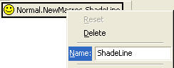
- Delete all the text in the text box, except for the word ShadeLine. (You delete the text in a text box by hitting the Backspace key on your keyboard.)
- Your button should now look like the one below:
That's much nicer. We can now start to record the macro for the button. So click the Close button on the Customize dialogue box.
You are returned to your Word document, and the little recorder will be on the page. Record the macro by doing the following.
- Click on Format from the menu bar
- From the drop down menu, click on Borders and Shading
- The Borders and Shading dialogue box appears
- Click the Shading tab strip
- Click a colored square for your Shading (We picked one of the grey squares.)
- Click the OK button at the bottom to close the dialogue box
- Click the recorder's Stop Recording button
- You macro is recorded. Time to test it out.
You will have a shaded line going across the page. Move your cursor down a few lines. If the shade moves with your cursor, get rid of the shading by clicking on Format > Borders and Shading. Select the Shading tab strip again, and click on No fill at top of the color squares. Click the OK button.
- So to test out your new macro, position your cursor at the start of a new line
- Click your new ShadeLine button
And that it is how to add a macro to the toolbar. If you got this far, and added a button to the toolbar, then very well done indeed! You're becoming something of a Word expert, because this is quite advanced Word Processing.

